## Name: Ahmed Mamdouh mohamed shousha

Section : 7

I.D: 149

Topik : artificial intelligence

Github link : <https://github.com/ahmed-momdoh/artificial-intelligence>

# Application brief:

At first, Khalifa confirms that the importance of artificial intelligence goes far beyond the idea of ​​a robot or a robot that works, thinks and feels like humans, or that surpasses humans in skill and intelligence, to the point that some have called for the development of human capabilities by implanting smart chips in their brains in order to match the capabilities of artificial intelligence, and with time, he becomes a human being. Half robot, the truth of the matter is related to a comprehensive value, moral and legal system that governs the interactions of new human life, that life that combines both robots and human beings, whose ultimate goal in the future may be to turn into a "full robot", instead of being a "half robot". human” due to the revolution of the intelligence industry.

Screenshots: 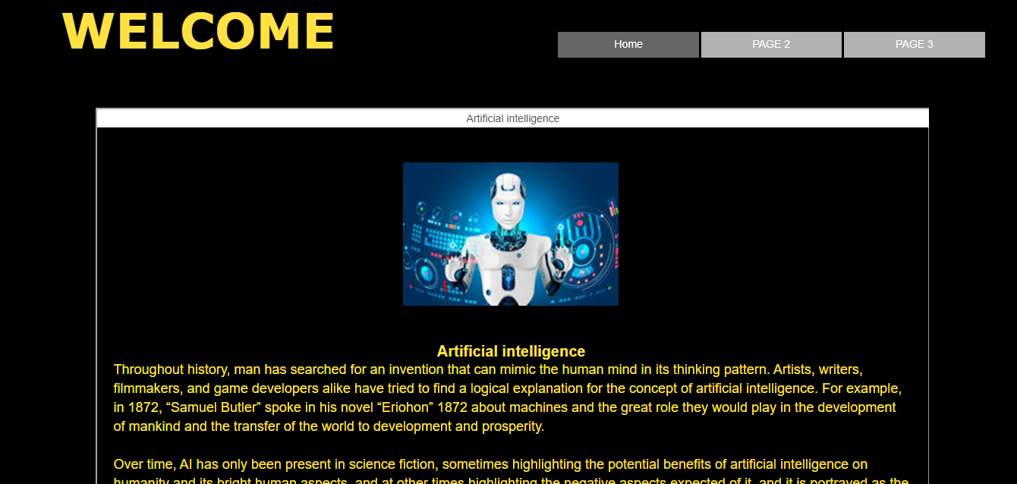

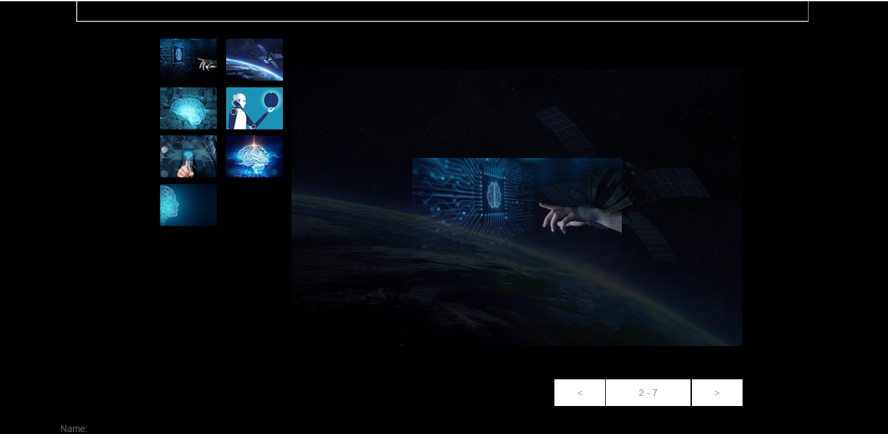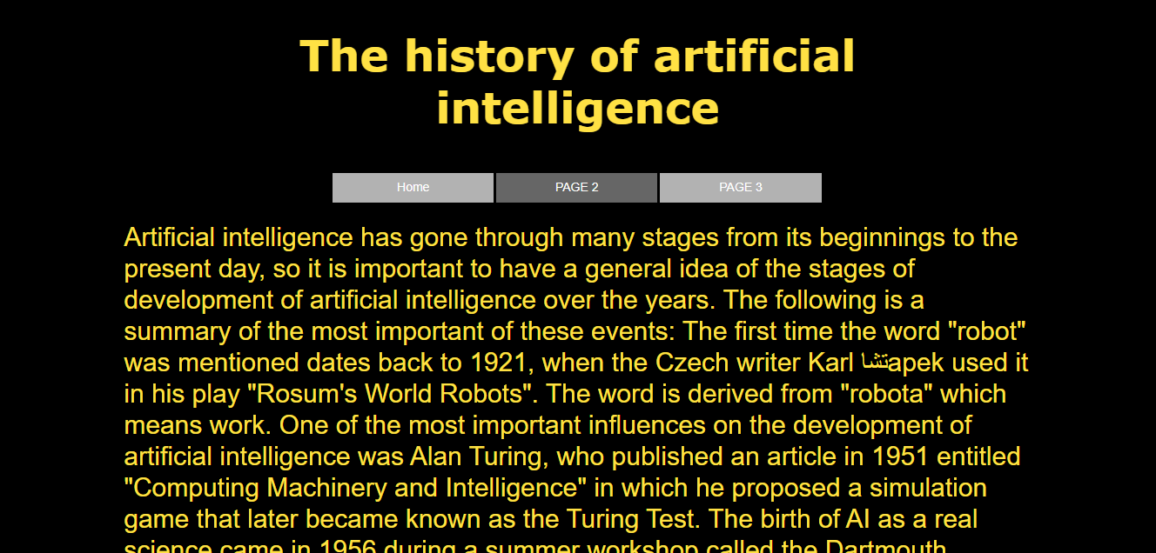

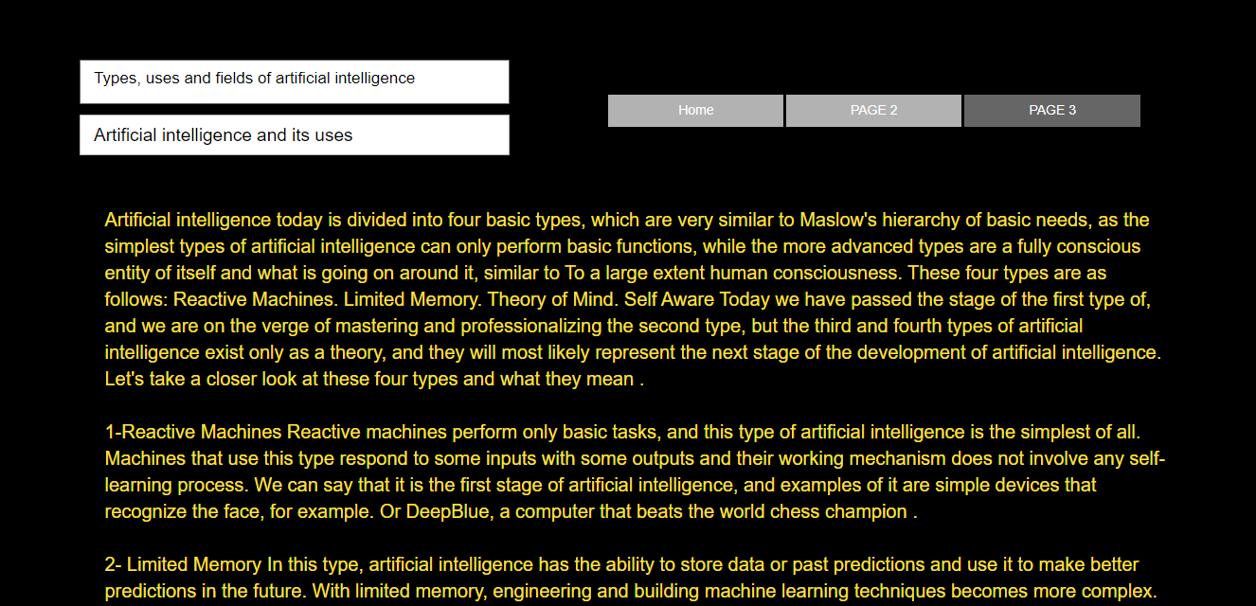

# Source code:

